- Configure VPC peering in cross regions.
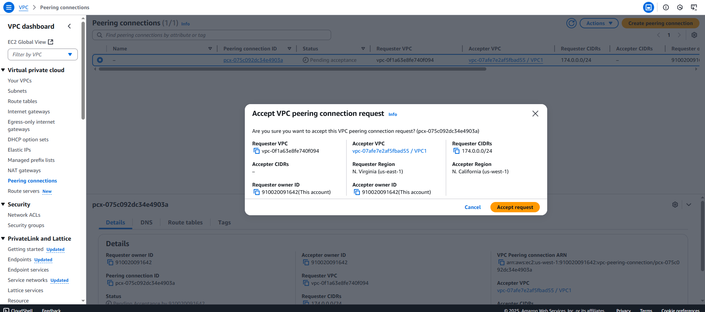
2) Purchase one domain from godaddy.
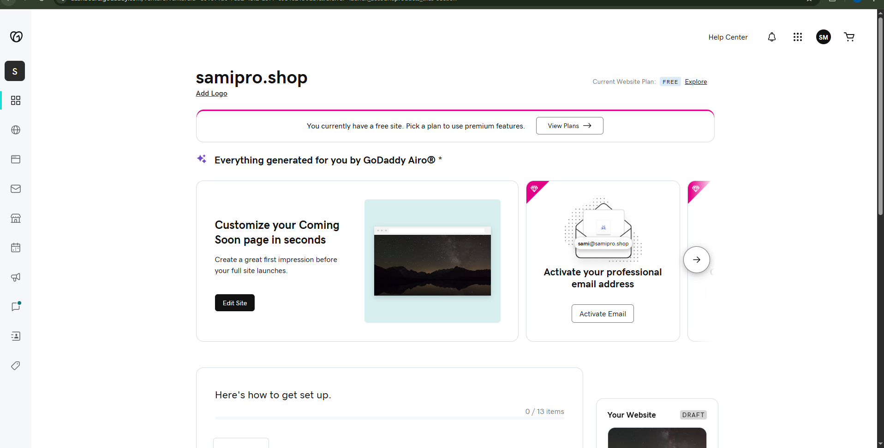

3)Deploy static webiste in s3.
Upload website files to s3
S3 ---> Buckets ---> select the bucket ---> objects ---> upload ---> Add
website files ---> upload
Select created files ---> Actions ---> make public using ACL ---> make
public
To enable static website hosting
S3 ---> Buckets ---> select the bucket ---> properties ---> Static website
hosting(enable) ---> Set index and error documents ---> save changes
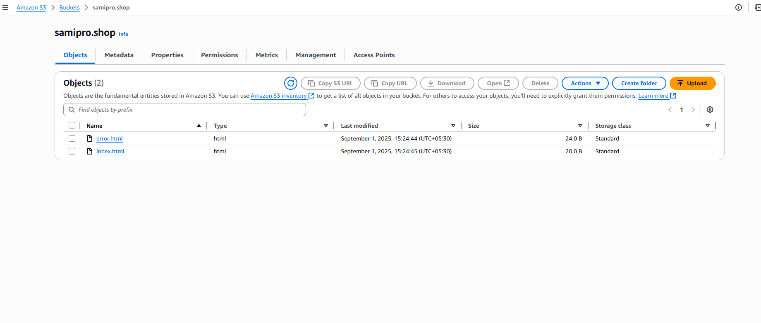

4) Create CDN and attach one SSL certificate.

CDN cloud front distribution network
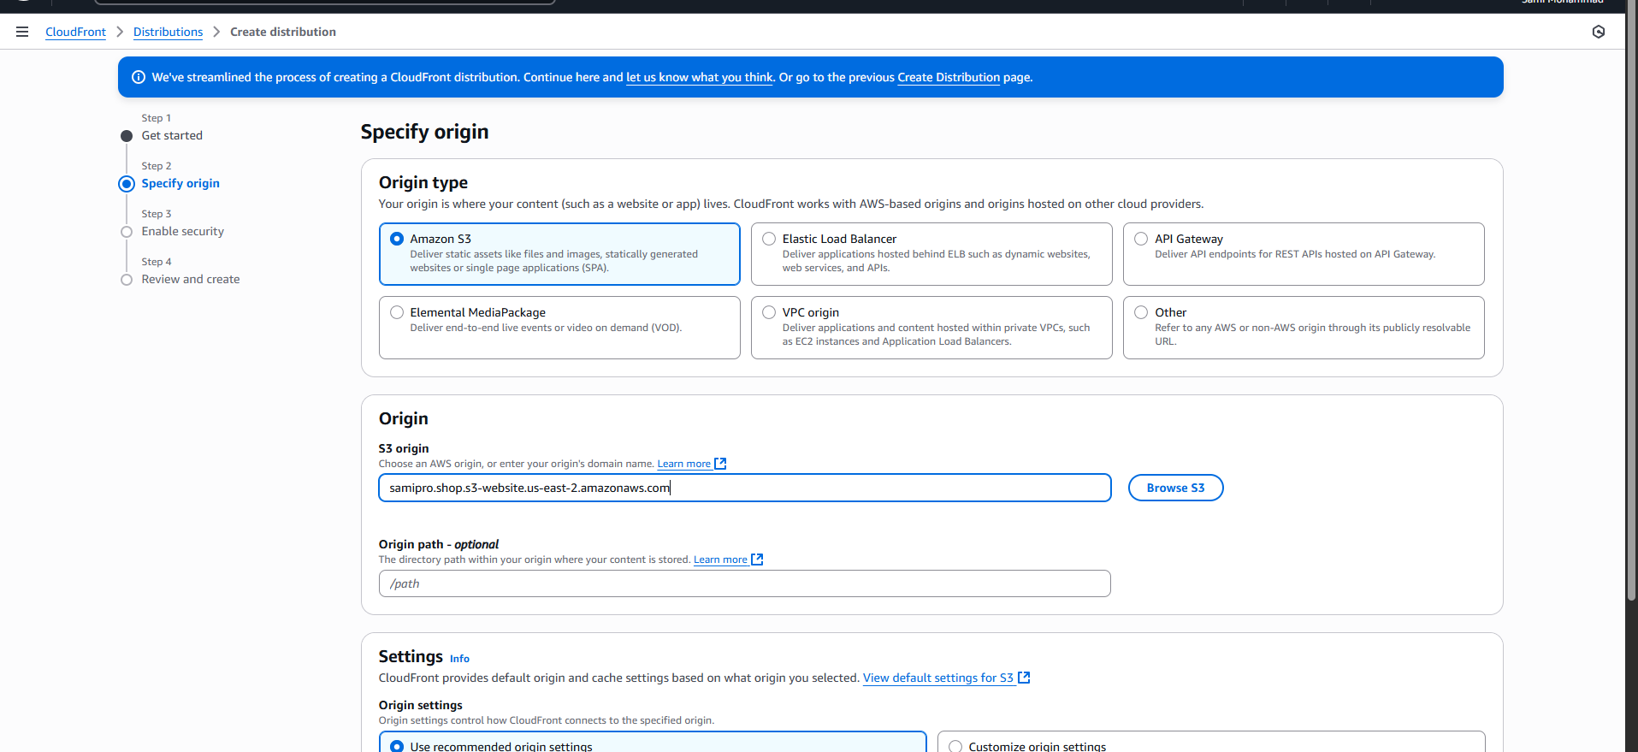
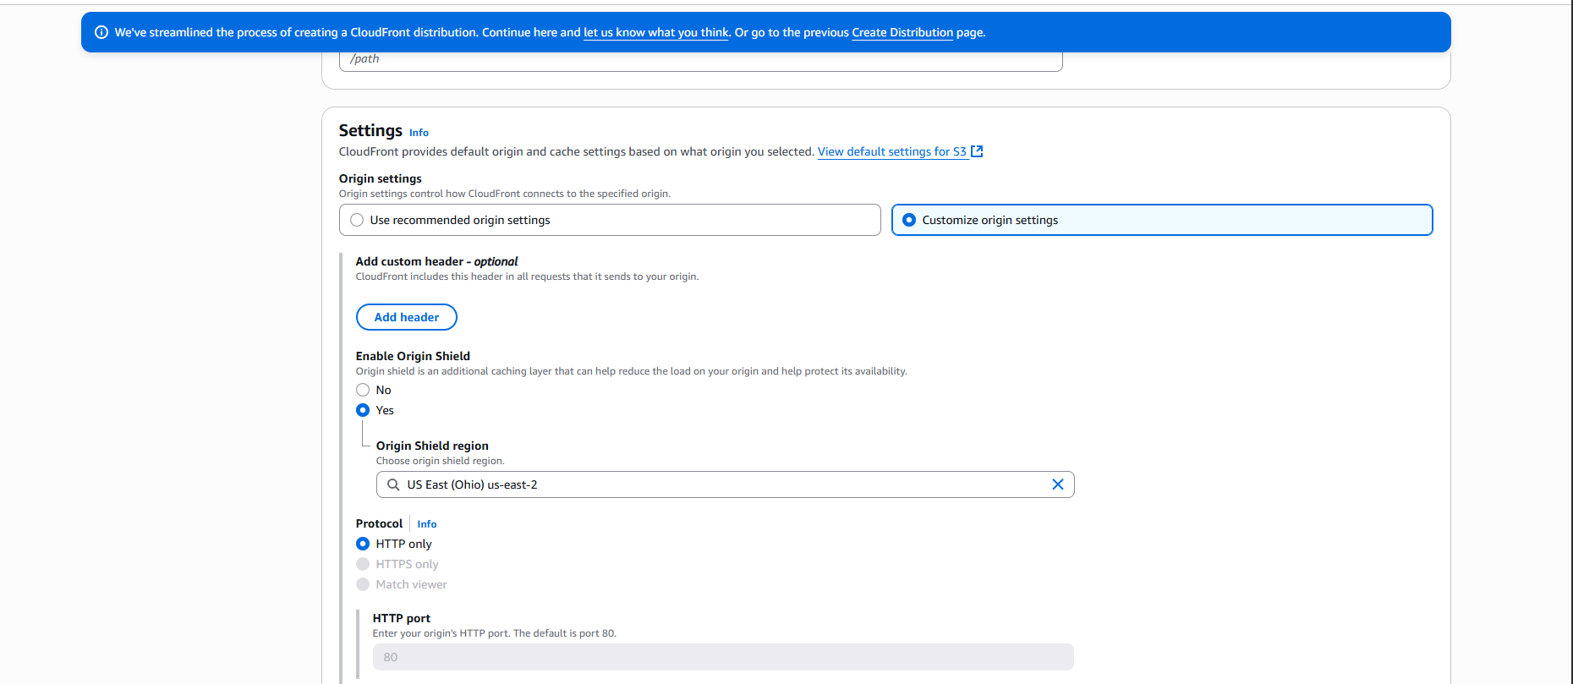
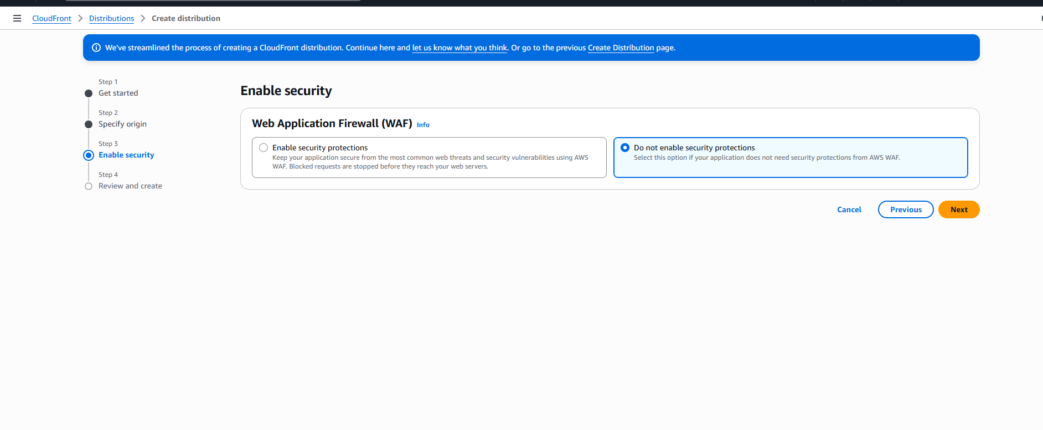
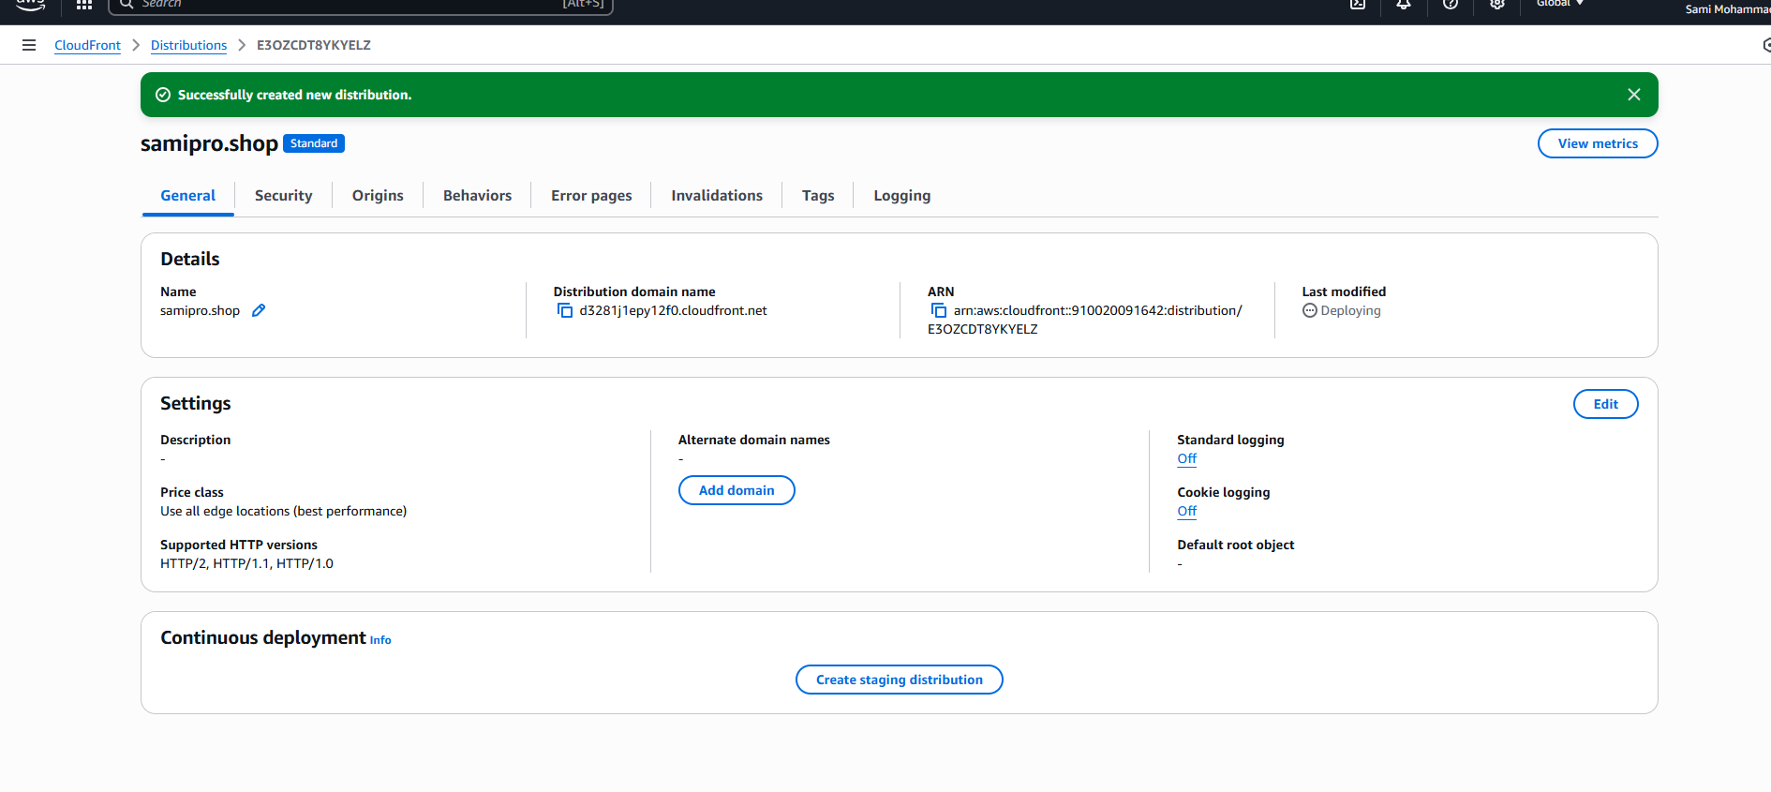
SSL certificate
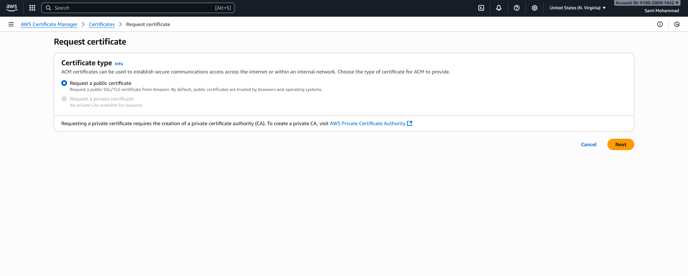
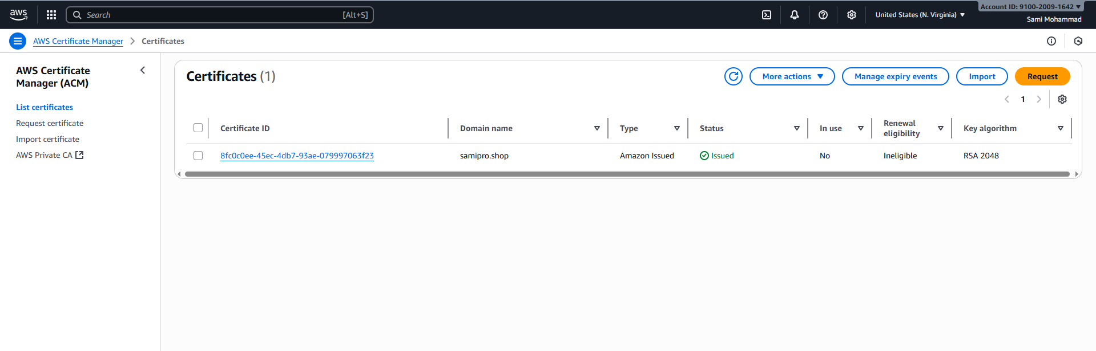

5) Create Route53 hosted zone and MAP the domain with CDN.
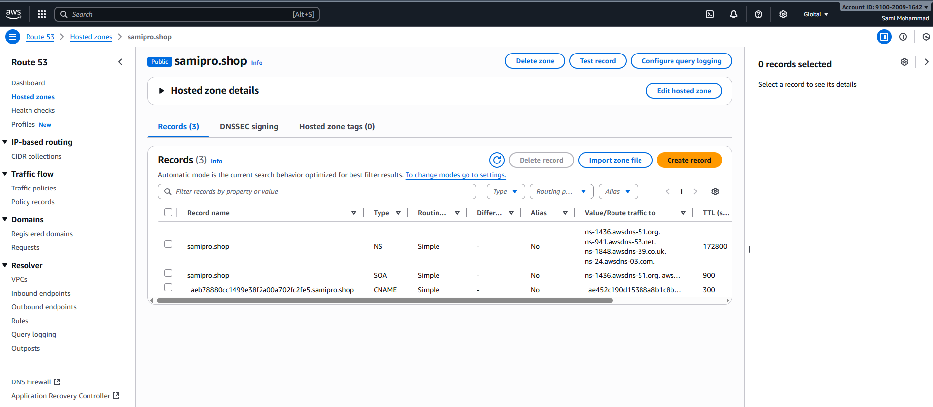
Go to godaddy and create our nameservers
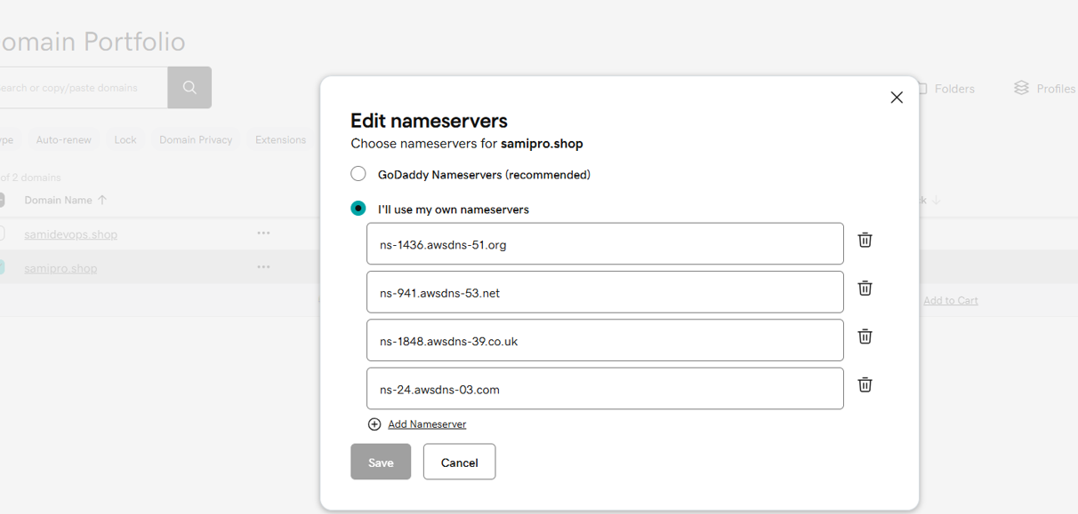

6) Update the index.html in s3 bucket and the updated file should be accessible by using domain name.
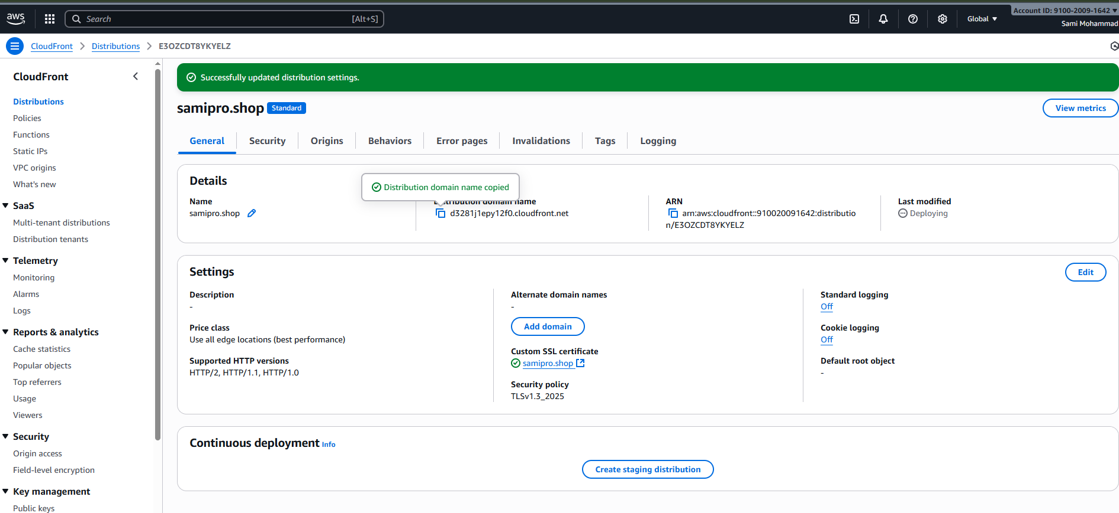

Below details Name is DNS distributed domain name DNS (hostname or this cloud front)
Means if you want to acess your S3 website, do not use S3 URL.
we can use DNS name copy this and paste on the browser.
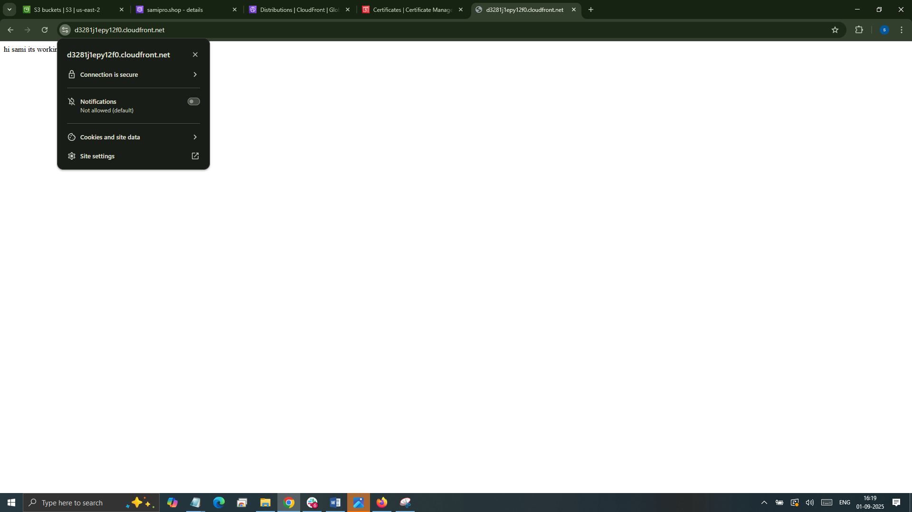

7) Share the Domain name in slack to test the connectivity.
